53. Create an alarm for a specific instance (e.g., monitoring a network load graph) and add it to an SNS topic to send email alerts.

54. Create an SNS topic and add an email address for notifications.

55. Create an SQS queue and subscribe it to the previously created SNS topic.

56. Verify if the messages are being sent correctly from SQS.

53. Create an alarm for a specific instance (e.g., monitoring a network load graph) and add it to an SNS topic to send email alerts.

* Created SNS topic
* SNS topic that will be used for sending email alerts.

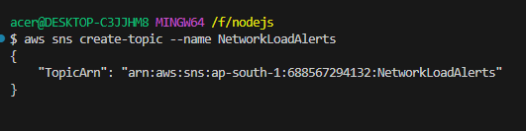

* Subscribe an Email Address to the Topic
* subscribe an email address to the SNS topic.

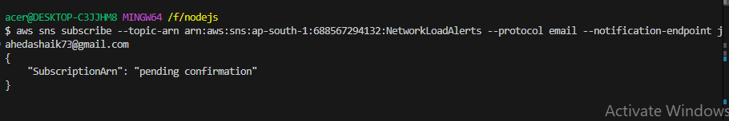

**Create an Alarm**:

* create an alarm for monitoring the network load

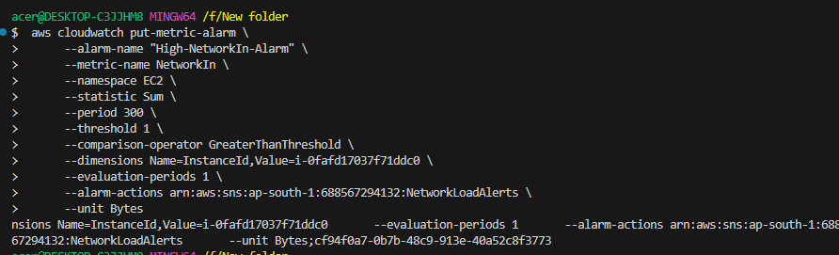

54. Create an SNS topic and add an email address for notifications.

* Created SNS topic

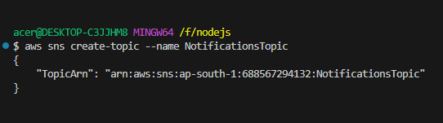

* Subscribe an Email Address to the Topic

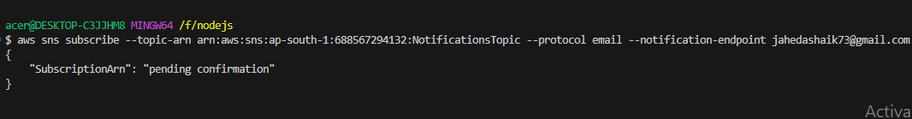

55. Create an SQS queue and subscribe it to the previously created SNS topic.

* Created an SQS Queue

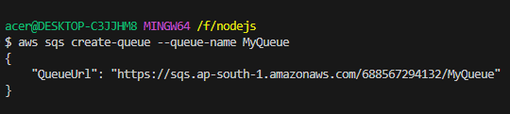

Get the SQS Queue ARN

* You need the ARN of the SQS queue to subscribe it to the SNS topic

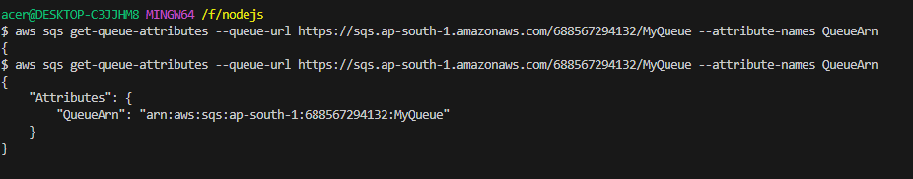

Subscribe the SQS Queue to the SNS Topic

* Now, use the ARN of the SQS queue and the SNS topic ARN to subscribe.

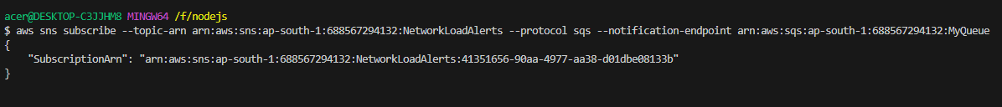

Set Queue Policy

* To allow SNS to send messages to the SQS queue, you may need to set a policy on the SQS queue.

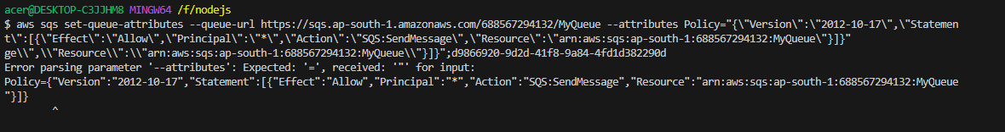

56. Verify if the messages are being sent correctly from SQS.

List SQS Queues:

Ensure the SQS queue exists by listing the available queues:

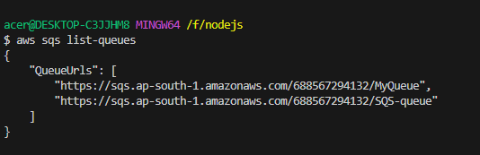

**Check Number of Messages in the Queue:**

check the number of messages available in the queue

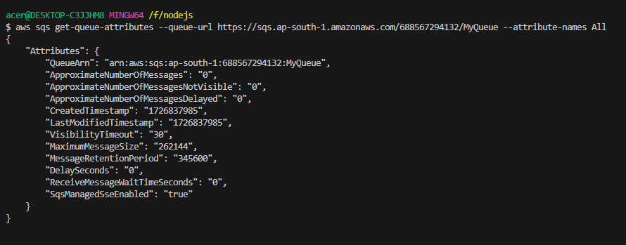

**Receive Messages from the Queue:**

retrieve messages from the queue to see if they're being sent correctly

